LARGE LANGUAGE MODELS

Lecture 2: Large Language Model (Basics)
- What is a Large Language Model (LLM)?
  - Deep Neural Networks are designed to understand, generate, and respond to human-like text, e.g., ChatGPT.
  - Trained on massive amounts of data.
- Why is it called “Large” Language Model
  - Large - Models have billions of parameters, and it is growing tremendously
  - Language Models - These models do a wide range of NLP tasks; question answering, translation, sentiment analysis and much more
  - LLMs mostly deal with Language
- Why have LLMs become so popular now? Didn't we have the field of NLP before also?
  - LLM vs Earlies NLP models
    - LLM - can do a wide range of NLP tasks
    - NLP models - designed for specific tasks like language translation, etc
    - Another difference in a different context is: “Earlier language models could not write an email from custom instructions, a task which is trivial for modern LLMs”
- What makes LLMs so good? What is their Secret?
  - Transformer Architecture - What does it mean? will be taught in subsequent lectures, with a focus on the 2017 paper, “Attention is all you need”.
- LLMs vs Generative AI vs Deep Learning vs Machine Learning
  - Try to paint a picture of what exactly these are and how you would define them and distinguish them appropriately - using a Venn diagram or concentric circles, giving stark examples on how different and varied they are.
  - Generative AI - Mix of LLMs and DL
    - Using Deep Neural Networks to create new content, such as text, images, videos, etc., but LLMs only deal with text
  - LLMs represent a specific application of deep learning techniques, leveraging their ability to process and generate human-like text
- Application of LLMs
  - Chatbots/Virtual assistant
  - Machine translation
  - Novel Text Generation
  - Sentiment Analysis
  - Content Creation

Lecture 3: Stages of Building an LLM
- Creating an LLM
  - It involves two major processes, which are: Pre-training and Fine-tuning
  - Pre-Training:
    - Training on Large, Diverse Datasets - More generalised, give insights on how OpenAI trained GPTs and how pretraining essentially works
  - Fine-Tuning:
    - Refinement by Training on a narrower dataset, specific to a particular task or domain. The reason is that specific industries and specific domains require specific expertise in a particular knowledge base. No one uses generalised models. It is a matter of subject expertise. Another name for a pretrained model is: Foundational Models
  - Pre-training and Fine-tuning Schematic
    - Step A: Data Collection (Corpus of raw data)
      - Internet text, books, media, research articles, etc - Raw, unlabeled text data → trillions of words
    - Step B: Pre-training (Training the model)
      - LLMs are getting trained on Unlabeled text data
      - Will have basic, generalised capabilities, serving as foundational models. Examples: ChatGPT, Gemini
    - Step C: Fine-tuning (Making it specifically talented in an area)
      - Pre-trained LLMs are trained again on labelled data. Examples: Using ChatGPT to finetune and get an LLM expert in Law, Coding, Maths, etc..

Lecture 4: Basic Introduction to Transformers
- Most Modern LLMs rely on the transformer architecture → a Deep neural network architecture introduced in the 2017 paper.
  - Attention is all you need, which is the foundation of the current GPT architecture.
  - At that time, it was proposed to do language translation tasks such as English to German translation and English to French translation.
- Simplified Toned-down Schematic of Transformer Architecture for Language Translation
  - Step 1: Input text to be translated
  - Step 2: Preprocessing Step. Input step prepared for the encoder
    - Done by a process called Tokenisation for now, think of it as breaking down large sentences into smaller words and assigning each word a Unique number or ID.
  - Step 3: Encoder - Most important step in the Architecture
    - Produces text encodings used by the decoder
    - Vector Embedding - Every sentence is broken down into individual words till now and given numerical IDs, but the most important part is that we need to encode the semantic meaning between the words. Represent the tokens in a way that captures the semantic meaning.
    - A very difficult task to perform
  - Step 4: Embeddings
    - Encoder returns embedded vectors as input to the decoder.
  - Step 5: Partial Output text
    - The model completes translating one word at a time
  - Step 6: Preprocessing
    - Along with the vector embeddings, even the partially translated text is fed into the decoder.
  - Step 7: Decoder
    - Generates translated text one word at a time. By predicting the rest of the text.
    - A decoder is something similar to a neural network
  - Step 8: Output Layer
    - The complete output - Full translated text
- Transformer Architecture main items
  - Transformer Architecture predominantly consists of an Encoder and a Decoder.
    - Encoder - Encodes input text into embedding vectors
    - Decoder - Generates output text from encoded vectors
  - A Note on Self-Attention Mechanism
    - A key part of Transformers. Allows the model to weigh the importance of different words/ tokens relative to each other
    - Enables the model to capture long-range dependencies
    - Covered in detail later..
- Later Variations of Transformer Architecture
  - BERT - Predicts hidden/masked words in a given sentence
    - Good at Sentiment analysis
  - GPT - Generates a new word, predicting the next word
- Transformers vs LLMs
  - Not all Transformers are LLMs
  - Transformers can also be used for Computer Vision
  - Not all LLMs are Transformers. also
  - LLMs can be based on recurrent and convolutional architectures as well.

Lecture 5: A Closer Look at GPT
- Zero-Shot vs Few-Shot Learning
  - Zero Shot - Ability to generalise to completely unseen tasks without any prior specific examples. The model performs a task without seeing any examples beforehand.
    - Completing a task without an example
  - Few-Shot Learning - Learning from a minimum number of examples that the user provides as input
    - Completing a task with a few provided examples
- Utilising Large Datasets
  - Pretraining of GPT-3
  - A token is a unit of text that the model reads
  - The total pre-training costs for GPTs can be around millions of dollars
- GPT: Generative Pretrained Transformers
  - GPT-3 is a scaled-up version of a transformer architecture
  - GPT models are simply trained on next word prediction tasks - unlabeled data
  - With this training, they can do a wide range of other tasks as well, like translation, spelling correction, etc..
  - Self-supervised Learning → self-labelling
  - We don't collect labels for training data, but use the structure of the data itself
  - Auto-regressive model: use previous outputs as inputs for future predictions
  - In the GPT architecture, there is no encoder; we just have the decoder
    - Original Transformer: 6-encoder decoder blocks
    - GPT-3: 96 transformer layers, 175 B parameters
  - Emergent Behaviour:
    - The ability of a model to perform tasks that the model wasn't explicitly trained to perform

Lecture 6: Stages of building LLMs
- Stage 1: Building an LLM (Understanding basic mechanisms)
  - Data Preparation and Sampling
  - Attention Mechanism
  - LLM architecture
- Stage 2: Pretraining the LLM (Building a Foundational Model)
  - Training Loop
  - Model Evaluation
  - Load Pretrained weights
- Stage 3: Fine Tuning
  - Classifier
  - Personal Assistant

Lecture 7: LLM Tokeniser from scratch in Python
- Data Preparation and Sampling
  - How do you prepare input text for training LLMs?
    - Step 1: Splitting text into individual words and subwords
    - Step 2: Convert these into tokens and token IDs
    - Step 3: Encode token IDs into a vector representation
- Now, let us look at Step 1: Tokenising the Text
  - Dataset used: The Verdict by Edith Wharton
  - Convert large sentences into words or subwords
  - Python code has been implemented for that
- Now, let us look at Step 2: Tokens → Token IDs
  - Complete training data set → tokenised text → Vocabulary
  - Vocabulary (A dictionary)
    - Sorting the tokens into alphabetical order and assigning each token a unique ID
    - So, essentially, a Vocabulary is a dictionary for all tokens. All tokens are mapped to unique IDs
  - Process of Encoding:
    - Sample text (The fox chased the dog) -> tokenized text(The|fox|chased|the|dog) -> token IDs (3 2 0 3 1)
  - Process of Decoding:
    - Exact vice-versa of the Encoding Process

Lecture 8: Byte-pair encoding (BPE)
- Tokenisation Algorithms:
  - 1. Word-based:
    - Every word in the sentence is a token.
    - Problems:
      - What to do with words that are out of the vocabulary?
      - What to do with different meanings of similar words, e.g, [boy, boys].
      - Root words aren't captured.

  - 2. Sub-word based:
    - BPE is an example of a subword-based tokeniser.
    - RULES:
      - 1. Do not split frequently used words into smaller sub-words.
      - 2. Split the rare words into smaller, meaningful sub-words.
      - E.g. “boy” should not be split if it appears often. But if “boys” is rare, split it into meaningful subwords: boy and s
    - Advantages:
      - 1. The subword splitting helps the model learn that different words with the same root word, like “token”, “tokens” and “tokenisation” are similar in meaning
      - 2. It also helps the model learn that “tokenisation” and “modernisation” are made up of different root words but have the same suffix “isation” and are used in the same syntactic situations.

  - 3. Character-based:
    - Every character in a word is a token. So the vocabulary is very small
    - Problems:
      - The meaning associated with words is completely lost.
      - Also, the tokenised sequence is much longer than the initial raw text, e.g. dinosaur in a word-based tokeniser has only one ID. But for a character-based tokeniser, it splits it into 8 token IDs.
- BPE algorithm:
  - The most common pair of consecutive bytes of data is replaced with a byte that does not occur in the data
  - Provide an apt example
- How is the BPE algorithm used for LLMs
  - BPE ensures that the most common words in the vocabulary are represented as a single token, while rare words are broken down into two or more subwords

Lecture 9: Create Input-Output (Target) Pairs
- The last step before we create vector embeddings is to create input-target pairs.
- How does an input-target pair look? Give noteworthy examples
  - Given a text sample
  - Extract input blocks as subsamples that serve as input to the LLM
  - The LLM's prediction task during training is to predict the next word that follows the input block
  - During training, we mask out all words that are past the target.
- So this is the reason they are called self-supervised models and are auto-regressive.
- Learned about context size, strides and batch size and implementation of this using datasets, dataLoaders package from PyTorch.
  - Context size = Maximum length of the input the LLMs see at one time.
  - To implement efficient dataLoaders, we collect inputs in a tensor x, where each row represents one input context. The second tensor y contains the corresponding prediction targets (next words), which are created by shifting the input by one position.
  - So, essentially, each input-output pair has 4 computations or prediction tasks. Here, 4 = context size. For example, if the context size is 6, there will be six prediction tasks because the input size can start from 1 to at most the context size, i.e. 6.
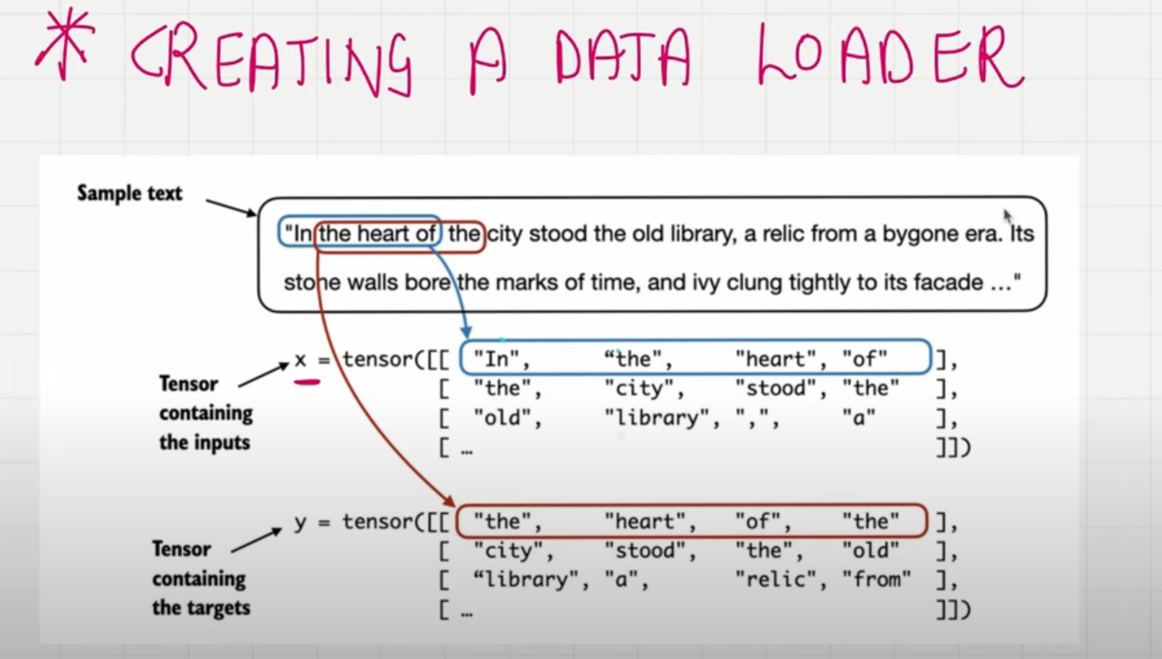

Lecture 10: Token Embeddings

1. Conceptual understanding of why token embeddings are needed.
- Representing words numerically
  - Computers need a numerical representation of words
  - How can we represent words in numbers?
    - Can we just assign random numbers to each word?
      - Cat → 34
      - Book → 29
      - Tablet → 47
      - Kitten → 354
    - The problem with random numbers assignment is that cat and kitten here are semantically related. However, the associated numbers cannot capture this relationship.
  - Semantically Similar words should have Similar vectors.

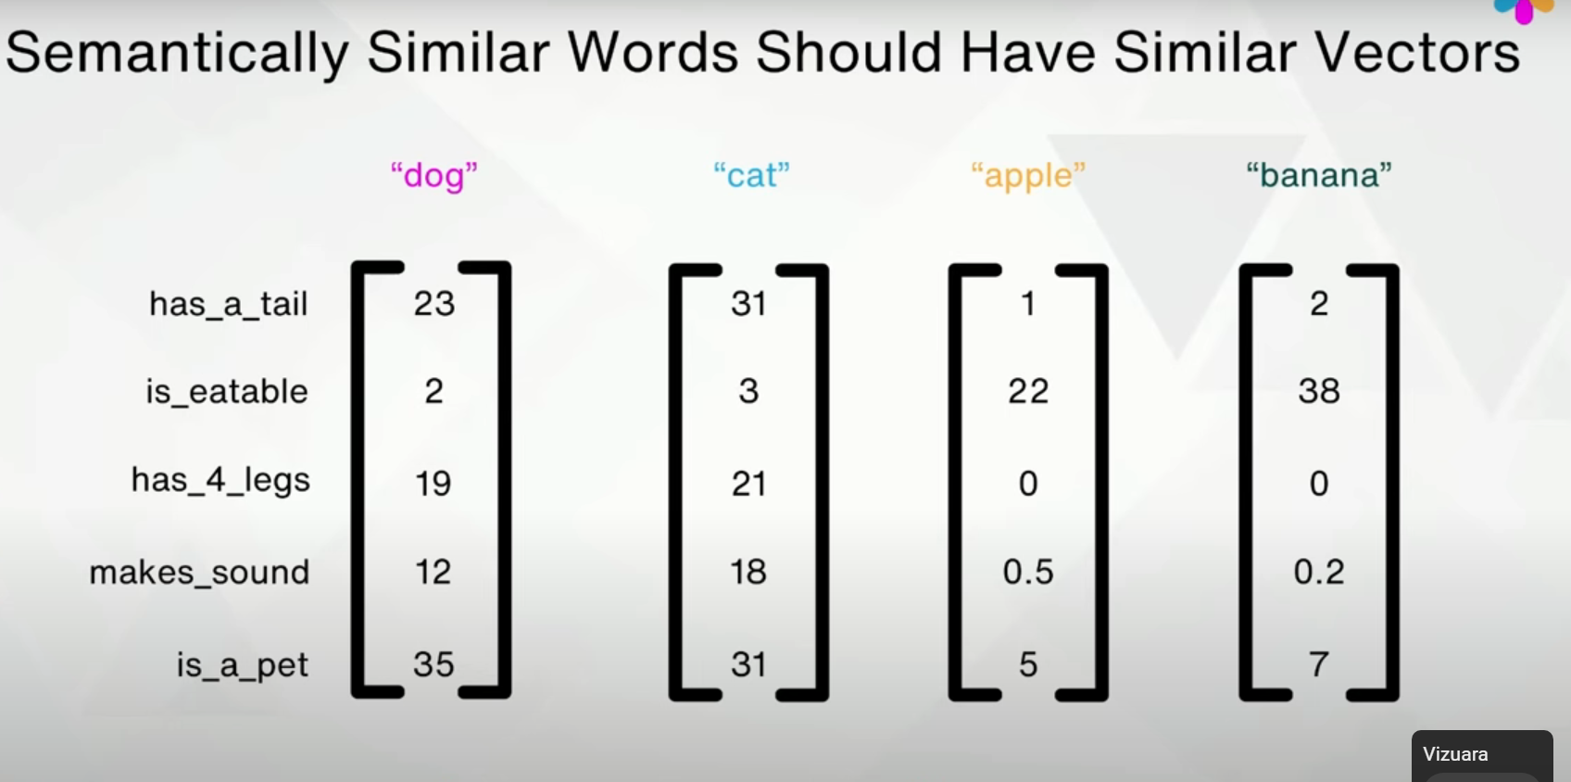
- Vectors can capture those semantic relationships.
- Now, how to come up with these vector embeddings? - Training a Neural network to create vector embeddings

2. Small hands-on demo - playing with token embeddings - Google’s pre-trained word2vec-googlenews-300

3. How are token embeddings created for LLMs
- Initialise embedding weights with random values
- This initialisation serves as the starting point for the LLM learning process.
- The embedding weights are optimised as part of the LLM training process
- Create an Embedding layer weight matrix, e.g. when GPT-2 was trained, it had 50257 tokens or vocabulary and for each vocabulary, a vector dimension of 768. So 50257(Rows) * 768(Columns) Vector dimension * Vocabulary size
- The embedding layer is a lookup operation that retrieves rows from the embedding layer weight matrix using token IDs

Lecture 11: Positional Embeddings

- In the embedding layer, the same token ID gets mapped to the same vector representation, regardless of where the token ID is positioned in the input sequence.
  - E.g. The cat sat on the mat, on the mat the cat sat
  - In sentences, there are meanings between different words, which we captured via vector embeddings, but the position of the words in the sentence also matters.
  - It is helpful to inject additional position information into the LLM

- Two types of positional embeddings:
  - Absolute:
    - For each position in the input sequence, a unique embedding is added to the token embeddings to convey its exact location
    - Token Embeddings + Positional Embeddings = Input Embeddings
    - The positional vectors have the same dimension as the original token embeddings
  - Relative:
    - The emphasis is on the relative position or distance between tokens. The model learns the relationship in terms of “How far apart” rather than at which exact position.
    - Advantage: The model can generalise better to sequences of varying lengths, even if it has not seen such lengths during training.
- Both types of positional encoding enable LLMs to understand the order and relationship between tokens, ensuring more accurate and context-aware predictions
- The choice between the two depends on the specific application and the nature of the data being processed.
- Even the positional embeddings, like the vector embedding, are optimised during the training process. The optimisation is part of the model training itself.
- Visualising the input data from the data loader:

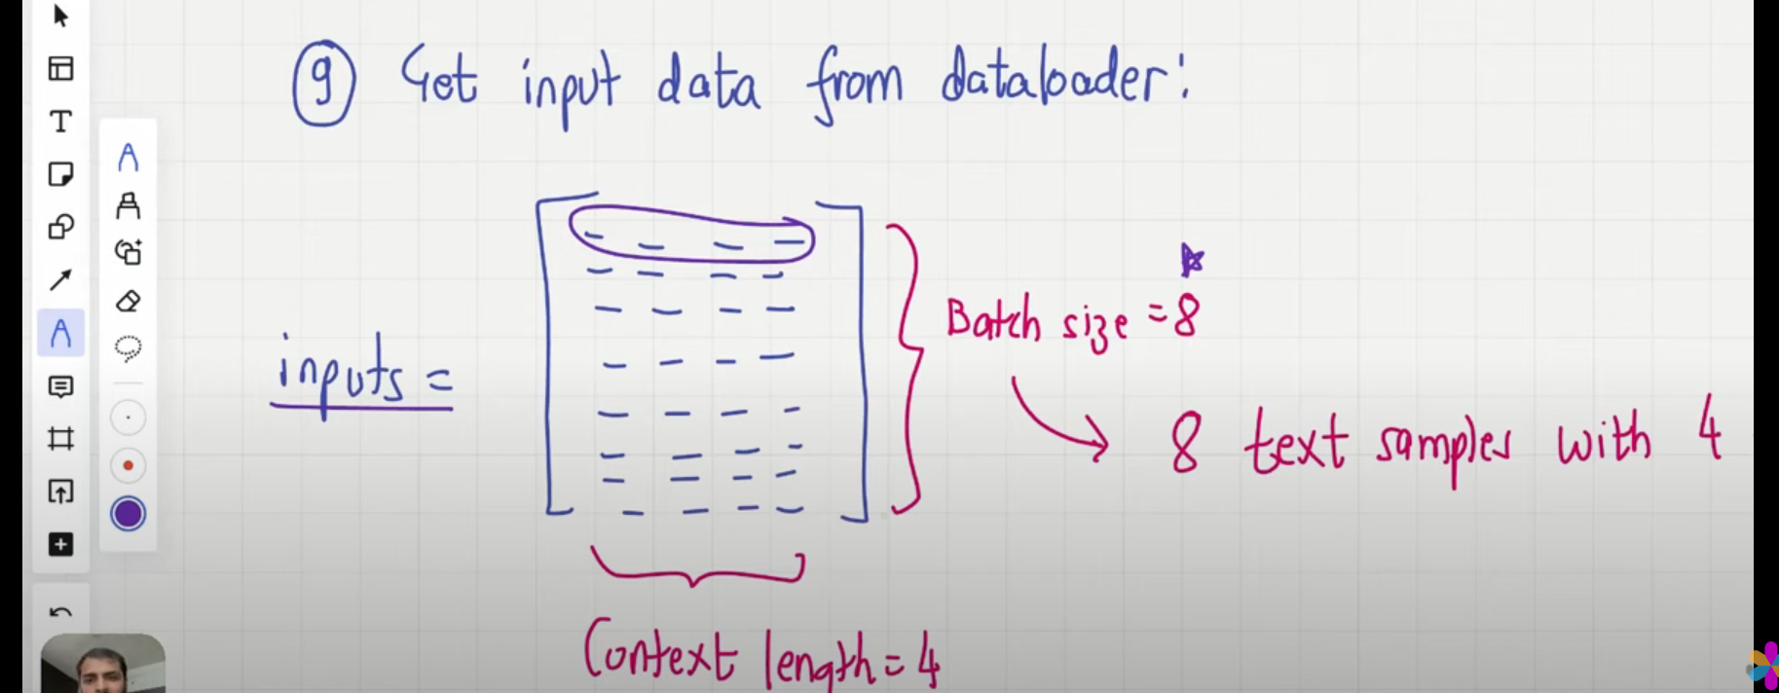
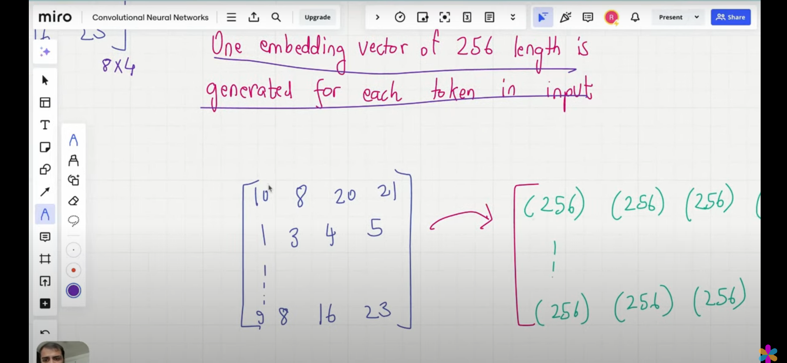

- Context_Length: A maximum of 4 tokens can be passed as Input at a time
- Batch_size: Parameters update after processing one Input box of size 8 rows
- Each row has 4 tokens, and a total of 8 rows are present, 32 tokens in one batch

Lecture 12: The Entire Data Preprocessing Pipeline of Large Language Models (Summary)
- Large Language Models predominantly deal with text and sentences, but we can't directly feed them into our language models. Hence, the Data Preprocessing requirement.
- 4 - Fundamental Steps are present in the Data Preprocessing pipeline:
  - 1) Tokenisation
  - 2) Token Embeddings
  - 3) Positional Embeddings
  - 4) Input Embeddings = Token Embeddings + Positional Embeddings

Lecture 13: Introduction to Attention Mechanism in LLMs
- 4 Types of Attention Mechanisms
  - Simplified Self-Attention
  - Self Attention
  - Causal Attention
  - Multi-head Attention
- To address the issue that we cannot translate text word by word, it is common to use a neural network with two submodules:
  - Encoder:
    - Reads and processes text
  - Decoder:
    - Translates the text
- Before transformers, Recurrent Neural Networks (RNNs) were the most popular encoder-decoder architecture for language translation
- Here is how the encoder-decoder RNN works:
  - Input text -> Encoder (Processes input text sequentially) -> Updates hidden state at each step (hidden state is the one which give memory to the neural network so it can understand context) -> Final hidden state (encoder tries to capture sentence meaning) -> Decoder (uses the final hidden state to generate translated text one word at a time)
- The encoder processes the entire input text into a hidden state (memory cell). Decoder takes this hidden state to produce the output.
- Issue with RNNs: RNNs cannot directly access earlier hidden states from the encoder during the decoding phase. It relies solely on the latest hidden state. This leads to a loss of context, especially in complex sentences where dependencies might span long distances.
- Capturing data dependencies with attention mechanisms
  - RNNs work fine for translating short sentences, but don't work for long texts as they don’t have direct access to previous words in the input.
  - One major shortcoming in this approach is that RNNs must remember the entire encoded input in a single hidden state before passing it to the decoder.
- Attention mechanism:
  - At each decoding step, the model can look back at the entire input sequence and decide which parts are most relevant to generate the current word
  - Dynamic focus on different parts of the input sequence allows models to learn long-range dependencies more effectively.
- Self Attention
  - In Self-Attention, the “ self ” refers to the mechanism's ability to compute attention weights by relating different positions in a single input sequence
  - It learns the relationship between various parts of the input itself, such as words in a sentence
  - This is in contrast to traditional attention mechanisms, where the focus is on relationships between elements of 2 different sequences

- Attention is like asking: “Which words from the input should I look at while decoding?”
- Self-Attention is like asking: “Which other words in this sentence help me understand this word?”

Lecture 14: Simplified Self-Attention Mechanism (W/o Trainable weights)

- Until now, we have covered how raw text is converted into vector embeddings through a series of processes:
  - 1) Break down the whole text into tokens (BPE) - a subword tokeniser.
  - 2) Convert the tokens into token IDs
  - 3) Convert the token IDs into Vector Embeddings, which contain both the semantic meaning of the word and the position of the word
- But the main problem arises when:
  - The cat that was sitting on the mat, which was next to the dog, jumped. → Here, the LLMs must understand that the cat was the one that jumped, not the dog.
  - Taking an example sentence: “Your Journey Starts with one step”
    - The vector embedding captures the meaning of the word “Journey”, but it does not capture how this word relates to the other words given in the sentence.
    - Or even better, we fail to capture how much attention we should give to each word relative to the word “journey”.
    - So the most important part, i.e Context, is missing till now.
    - Goal: Take the Embedding Vector -> Context Vector (Enriched version of Embedding Vector).
    - Context Vector: Not only contains the semantic meaning, but also how that particular word (token) is related to the other words in the sentence.

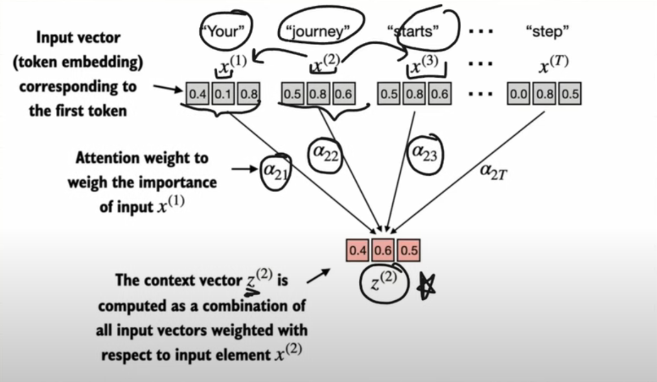

- Goal of self-attention:
  - Calculate a context vector (Z^{i}) for each element (X^{i})
- “Your Journey Starts with one step”
- 1) Input Sequence (X):
  - X¹,X²,...X^{t} - Token embeddings representation.
- 2) Focusing on Second Element (X²) = Journey
  - The corresponding context vector is Z²
  - The element we are looking at currently is also called “query”.
  - Z² is an embedding that contains information about X² and all other input elements X¹ to X^{T}
- 3) Later, we will add trainable weights that help the LLM learn to construct these context vectors, so that they are relevant for the LLM to generate the next token
- 4) The first step of implementing self-attention is to compute the intermediate values W, also referred to as attention scores.

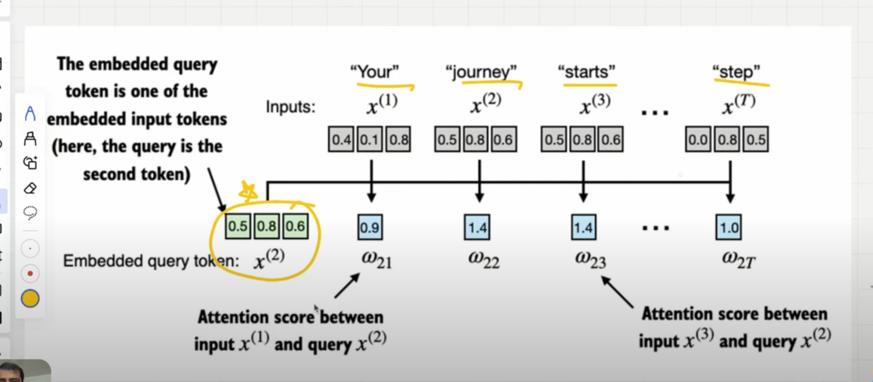

- 5) The intermediate attention scores are calculated between the query token and each input token - Using DOT PRODUCT
  - The Dot Product quantifies how much two vectors are aligned
  - The higher the dot product, the higher the similarity and attention scores between the two elements
- 6) After the dot product, we enter the process of normalisation
  - This improves interpretability and makes sure the value is between 0 & 1 because models can be trained better and can be used to tell percentage-wise how much attention Journey should give to “your” or “step” just like that.
- 7) After computing the normalised attention weights, we calculate the context vector Z² by multiplying the embedded input token X^{i} with the corresponding attention weights and then summing the resultant vectors

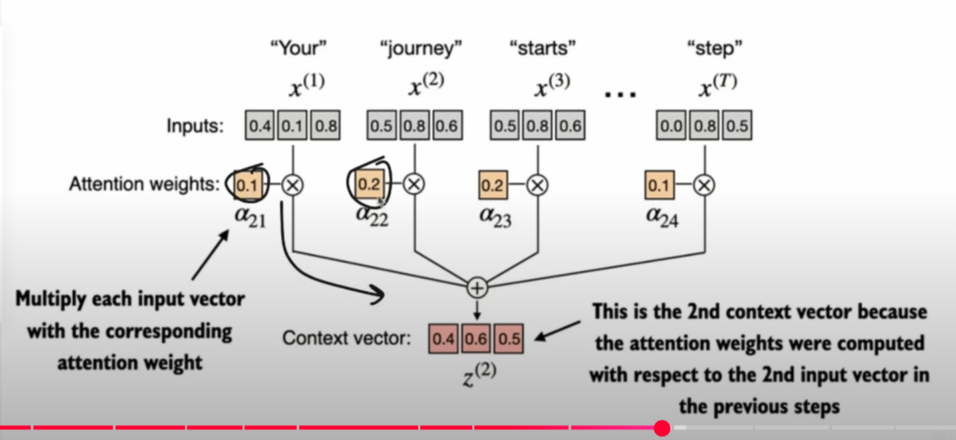

- 8) Computing attention weights for all input tokens:
  - We can extend similar computation as before to calculate attention weights and context vectors for all inputs.
  - NOTE: Attention Weights are the normalised version of Attention Scores

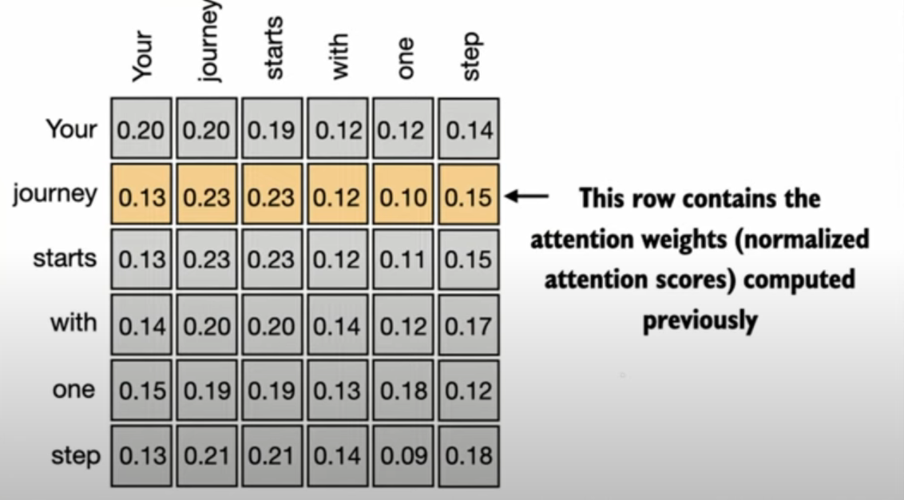

- Summary:
  - 1) Compute attention Scores - dot products between input embeddings
  - 2) Compute attention Weights - Normalising using the soft max function
  - 3) Compute context vectors - The context vectors are computed as a weighted sum over the inputs

Lecture 15: Self-Attention Mechanism With Trainable Weights
- In this section, we will learn about the self-attention mechanism used in the original transformer architecture, the GPT models and most other popular LLMs
- Self-attention mechanism is also called “scaled dot-product attention”
- Steps:
  - We want to compute context vectors as weighted sums over the input vectors specific to a certain input element
  - We will introduce weight matrices that are updated during model training
  - These trainable weight matrices are crucial so that the model can learn to produce good context vectors
  - We will implement the self-attention mechanism step by step by introducing 3 trainable weight matrices: W_{q}, W_{K}, W_{V}
    - These 3 matrices are used to project the embedded input tokens X^{i} into Query, Key, and Value vectors

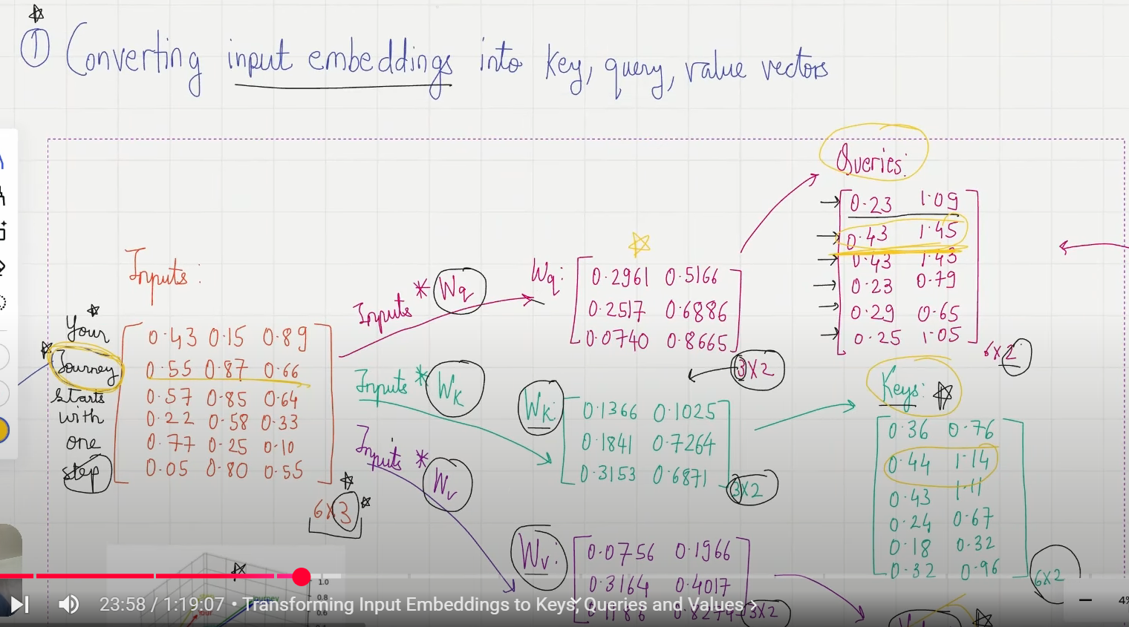

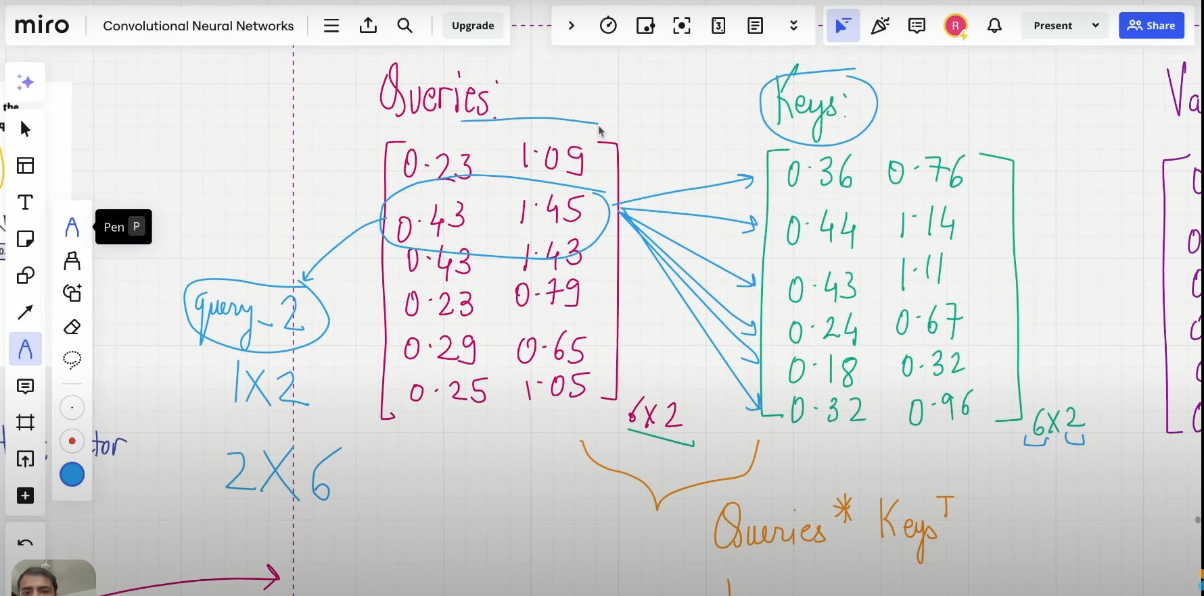

Step-by-Step rules:
- We convert the Input Embedding Matrix into 3 Matrices (Key, Query, Values) by multiplying it with Weight matrices W_{k}, W_{q},W _{v}
- Now, once we get these 3 matrices, we want to find the attention scores for all the tokens
  - We do that by getting the Dot Product between Queries and the Key Matrix.
- Once we get the attention scores by the dot product operation, we scale the attention score matrix by the square root of D, where D is the dimension of keys; here, it is 2, and this is an important step to make sure learning is stable.
- After that, we normalise the attention score matrix by softmax to get the attention weight matrix, which is interpretable.
- Whatever has been done until now:

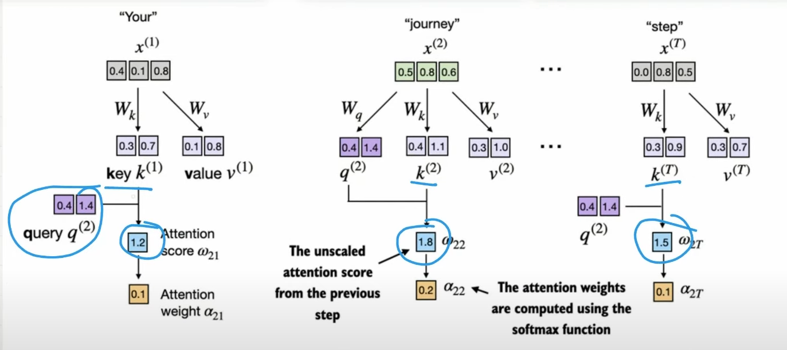
- Now multiply the Attention weight matrix with the Value Matrix, which will give you the Context Vector for each token.

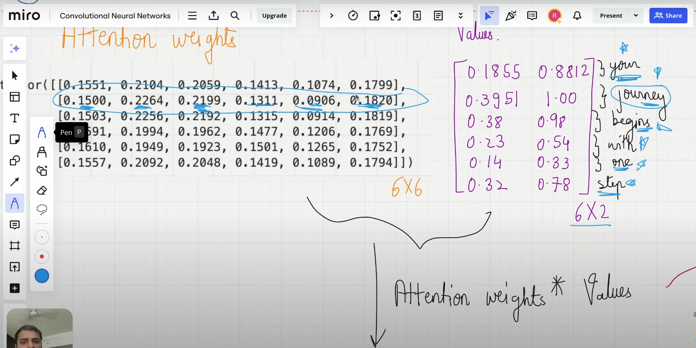

Final Schema:

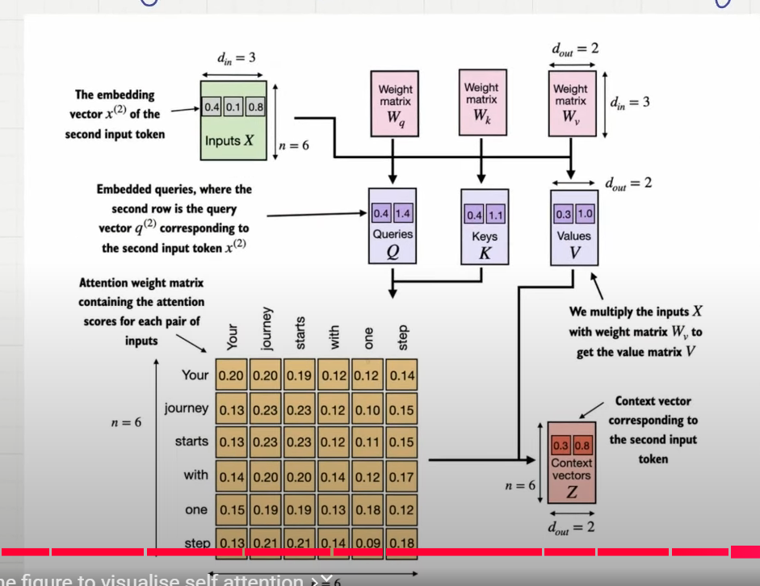

Lecture 16: Causal Attention
- Causal attention, also known as masked attention, is a special form of self-attention
- It restricts the model to only consider previous and current inputs in a sequence when processing any given token.
- This is in contrast to the self-attention mechanism, which allows access to the entire input sequence at once.
- When computing attention scores, the causal attention mechanism ensures that the model only factors in tokens that occur at or before the current token in the sequence
- To achieve this in GPT-like LLMs, for each token processed, we mask out the future tokens, which come after the current token in the input text

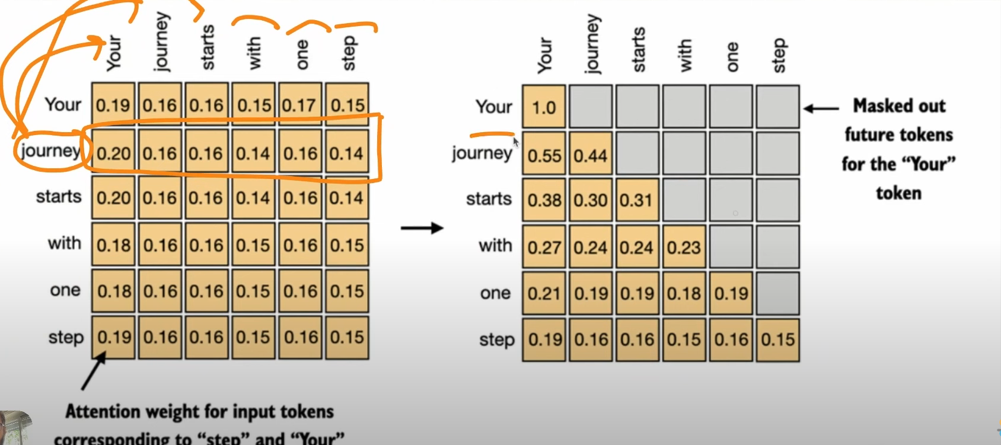

- Applying Causal Attention Mask
  - Get Attention weights → Zero out the elements above the diagonal and normalise the resulting matrix. Normalise here is to make sure the sum adds up to 1.
- Flow Map:
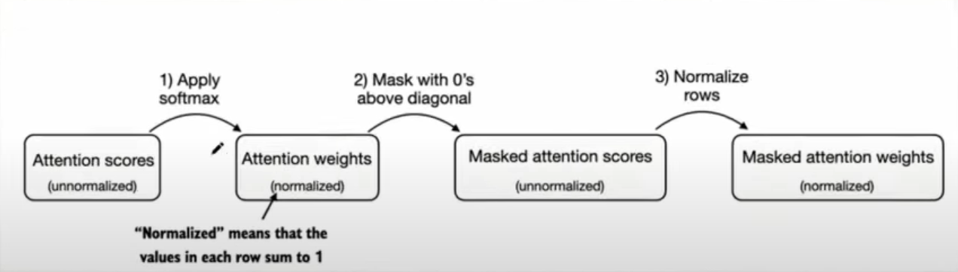

- But there is a problem. The Entire Point of masking out future elements is that these elements should not influence the current token. But we are already getting influenced because in the 1st step itself, we are applying softmax to get attention weights, which already uses future elements that we want to mask - this is called the Data Leakage Problem
- We need to tackle this problem by
  - Attention Scores → Upper Triangular Infinity Mask → Softmax

Lecture 17: Multi-Head Attention Part 1:
- The term “multi-head” refers to dividing the attention mechanism into multiple heads → each operating independently
- Stacking multiple single-head attention layers
- Implementing multi-head attention involves creating multiple instances of the self-attention mechanism, each with its own weight and then combining their outputs
- This can be computationally intensive, but it makes LLMs powerful at complex pattern recognition tasks

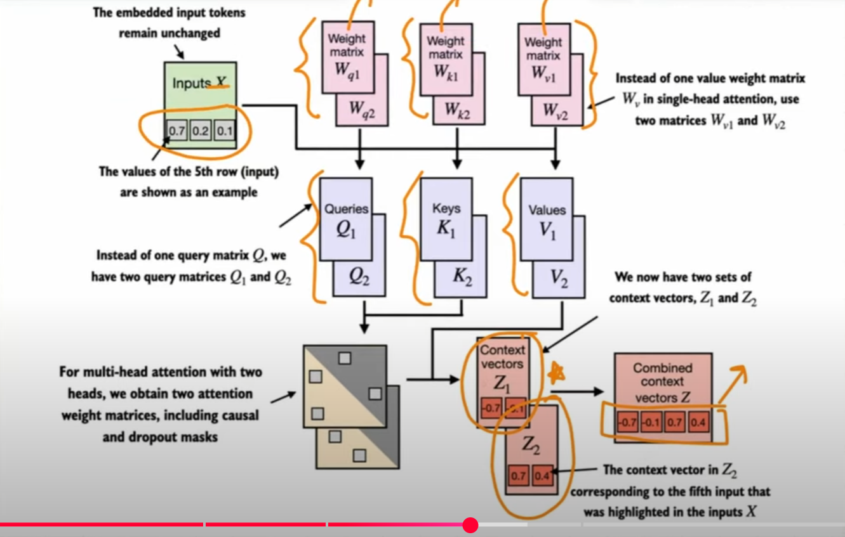

- Run the attention mechanism multiple times (in parallel) with different, learned linear projections:
  - The result of multiplying input data (like query, key, value vectors) by a weight matrix

Lecture 18: Multi-Head Attention Part 2:
Let us take a simple example:
- Step 1: Start with the Input.
  - b,num_tokens,d_in =(1,3,6)
  - Where b is the batch size, num_tokens is no of tokens present in the input embedding tensor, d_in is the input vector dimension, which is basically the dimension of each token present in the input embedding vector.
  - 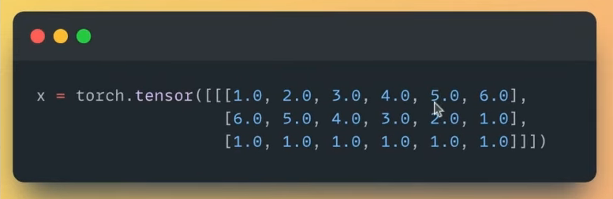

- Step 2: Decide d_out, num_heads
  - The ultimate goal is to get a context vector from the input embeddings, and we need to decide upon the output dimensions for the context vector, which is d_out
  - In this example, since we have 3 tokens, the context vector will have a dimension like this: 3 x d_out.
  - We have to decide d_out. For this example, we take d_out=6, typically in GPT models (d_in = d_out).
  - num_heads is basically no of attention heads used. In GPT3, we use 96 attention heads. In this example, we take num_heads=2
  - Each head will have a dimension which is called head_dim = (d_out/num_heads); here, it is 6/2 = 3.

- Step 3: Initialise trainable weight matrices for key, query, value (W_{k}, W_{q}, W_{v})
  - Dimensions of these trainable matrices are (d_in x d_out) here it is 6x6
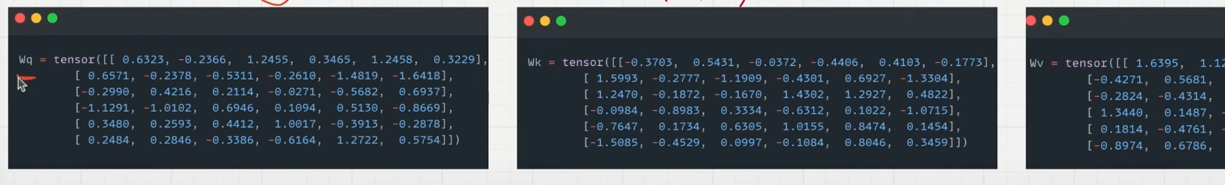
- Step 4: Calculate Keys, Queries, Value Matrices
  - Input * ( Trainable Weight Matrices)
  - Input Matrix dimension = 3x6
  - Trainable Matrices dimension = 6x6
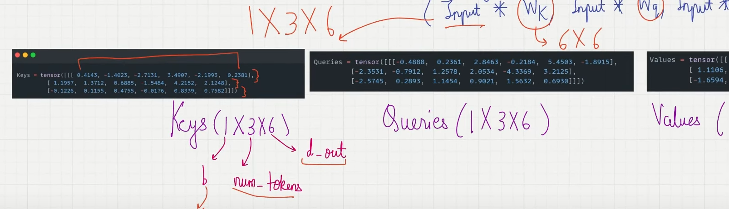
- Step 5: Unroll the last dimension of Keys, Queries and Values to include num_heads and head_dim
  - head_dim =3
  - (b,num_tokens, d_out) → (b,num_tokens,num_heads,head_dim) replacing d_out with num_heads and head_dim
  - (1,3,6) → (1,3,2,3)
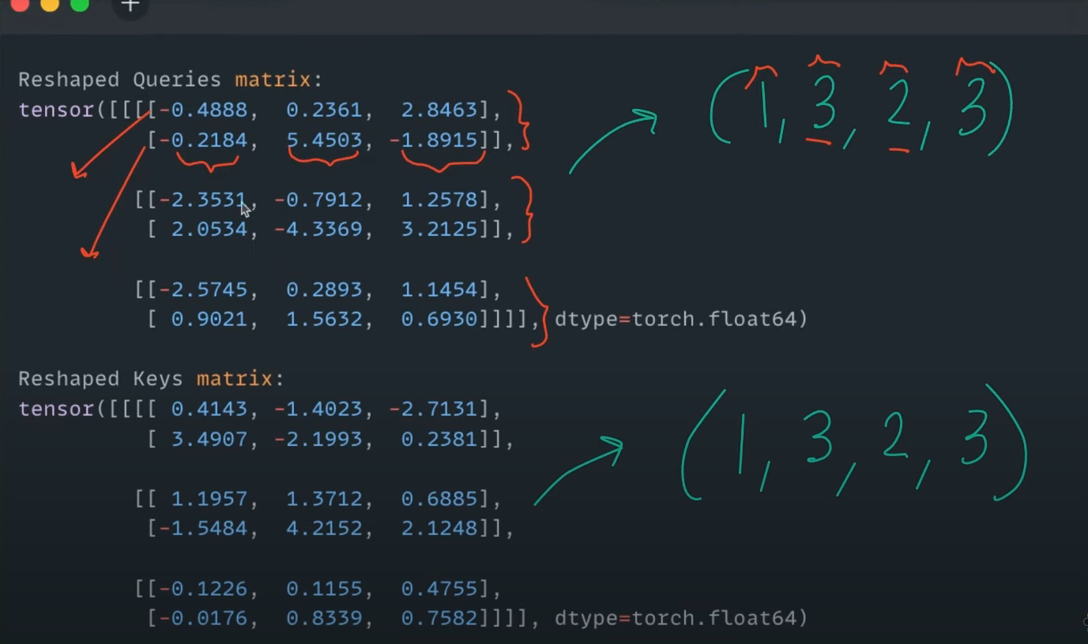
  - Interpreting 4 dimensional tensors use chat-GPT (1,3,2,3) -> 1 represents batch_size since it is 1 now leave it
  - 3 represents no of tokens, so a total of 3 rows, where each token has 2 attention heads, and each attention head has a dimension of 3
- Step 6: Group matrices by “number of heads” instead of number of tokens
  - (b,num_tokens,num_heads,head_dim) → (b,num_heads,num_tokens,head_dim)
  - (1,3,2,3) → (1,2,3,3)
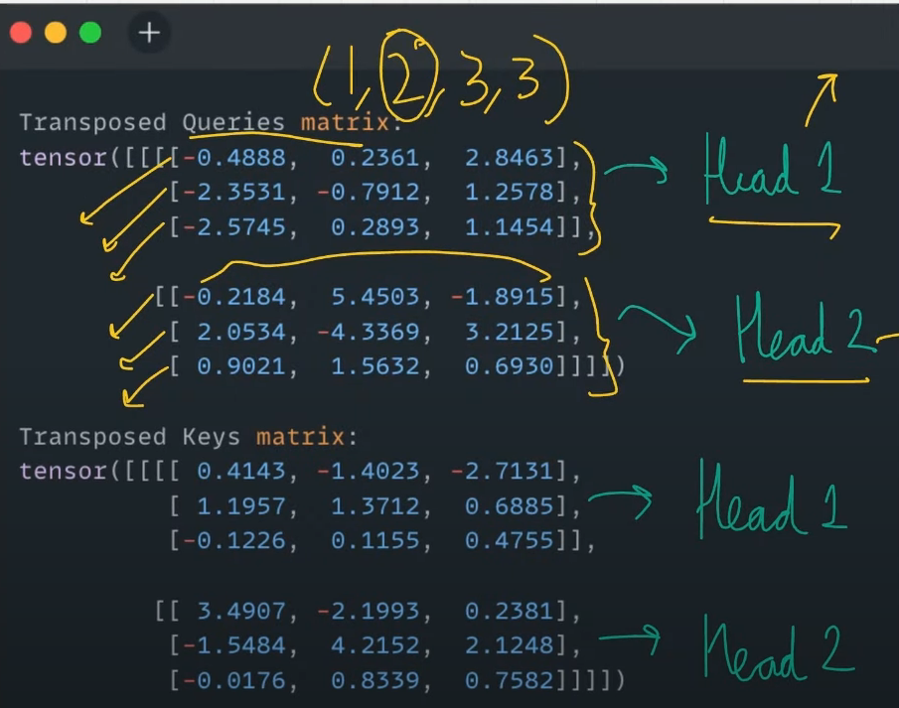
- Step 7: Find Attention Scores
  - Queries x Keys Transpose (2,3)
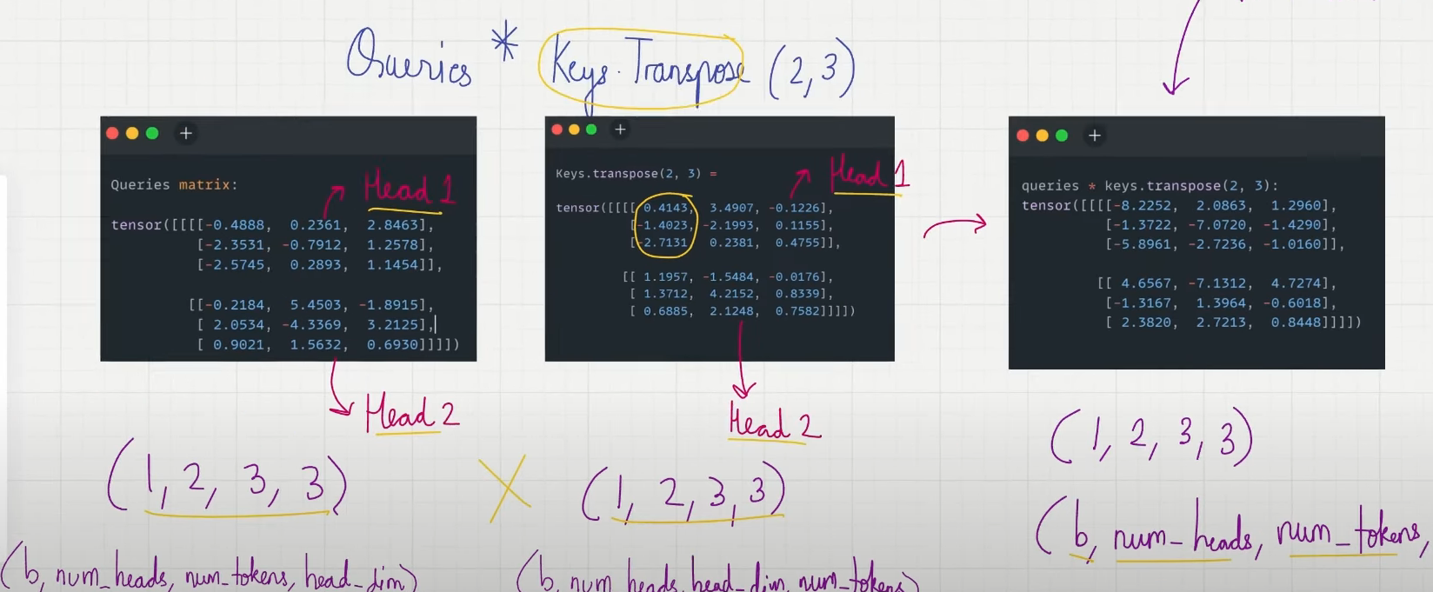
- Step 8: Find Attention Weights
  - Mask attention scores to implement causal attention
  - Scale by the root of head_dim and use the softmax function
  - Implement dropout as well
- Step 9: Computing the Context vector
  - Context Vector = Attention weights * Values
  - Attention weights (b,num_heads,num_tokens,num_tokens) x Values (b,num_heads,num_tokens,head_dim)
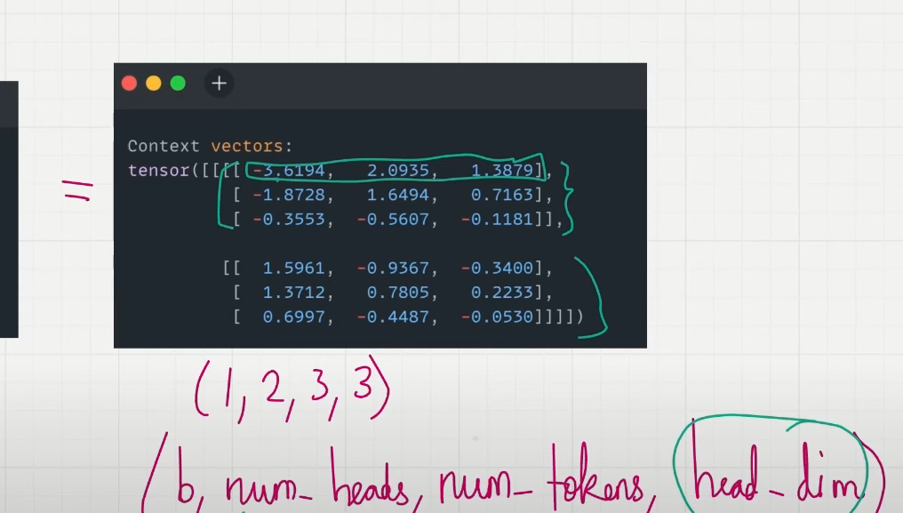
- Step 10: Reformat context vectors
  - (b,num_heads,num_tokens,head_dim) → (b,num_tokens,num_heads,head_dim)
  - Transpose of 1st and 2nd Index
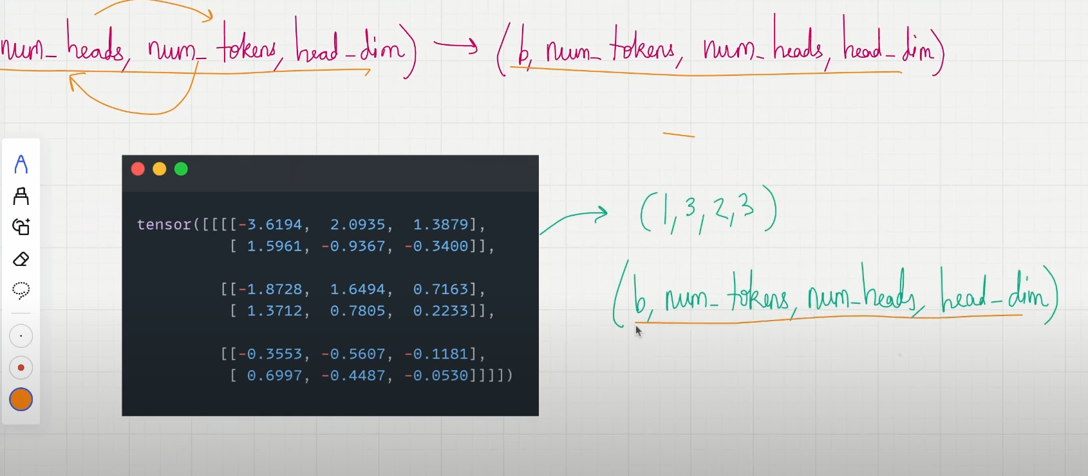
- Step 11: Combine Heads
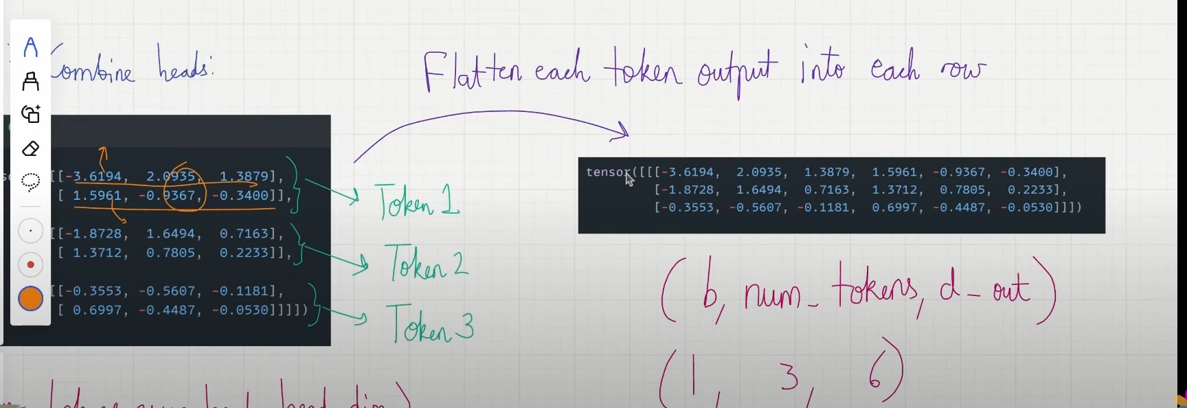

Lecture 19: Bird’s-Eye View of the LLM Architecture

After learning about the attention mechanism, let us learn about the LLM architecture now.

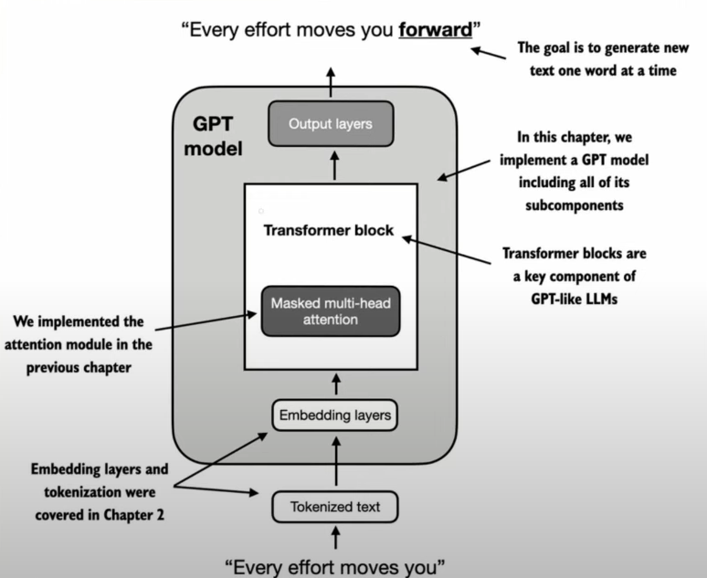

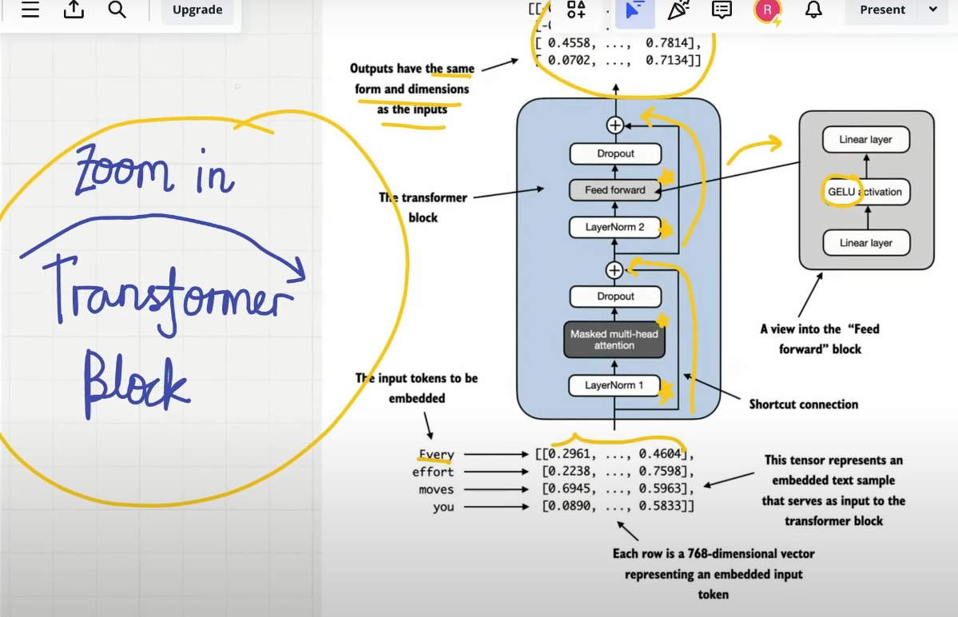

What are we yet to learn?
- Transformer block
- We will scale up to the size of a small GPT-2 model → 124 million parameters

Configurations we are going to use:
- N_layers = no of transformer blocks

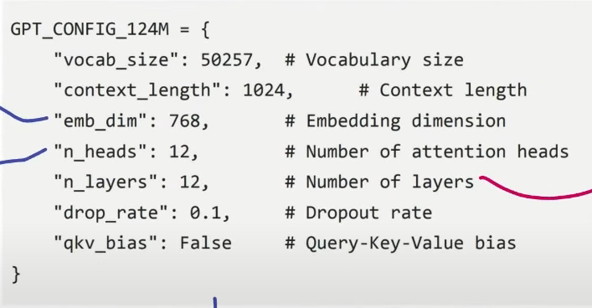

Using this configuration, we will build a GPT placeholder architecture. The skeleton for the code

Entire Transformer Block and things to do for the upcoming Lectures Layout
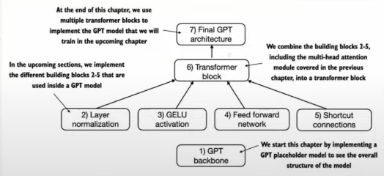

Lecture 20: Layer Normalisation

- Training deep neural networks with many layers can be challenging due to the Vanishing/Exploding Gradients problem.
- This leads to unstable training dynamics.
- Layer normalisation improves the stability and efficiency of neural network training

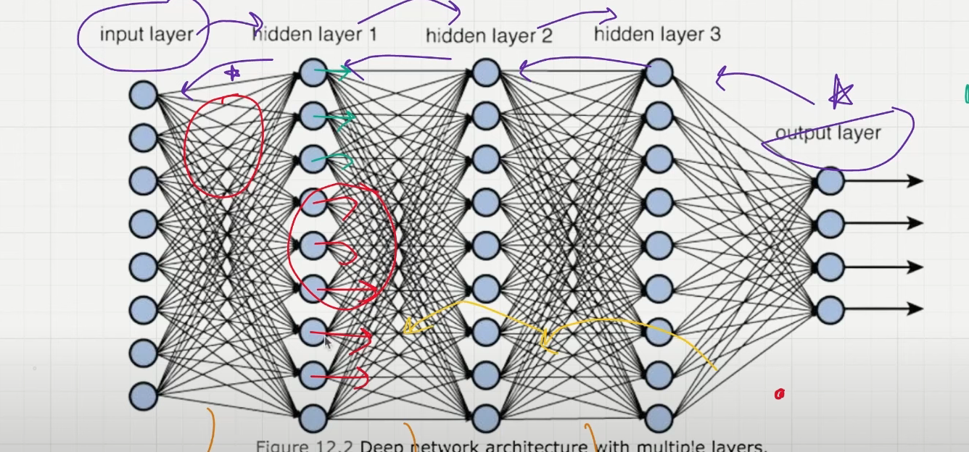

Why do we use Layer Normalisation?
- If the layer output is too large or small, gradient magnitudes can become too large or small - this affects the training
- As the training proceeds, inputs to each layer can change (Internal covariate shift) → This delays convergence

Main idea of Layer Normalisation:
- Adjust outputs of neural network to have mean = 0 and variance = 1
- This speeds up the convergence
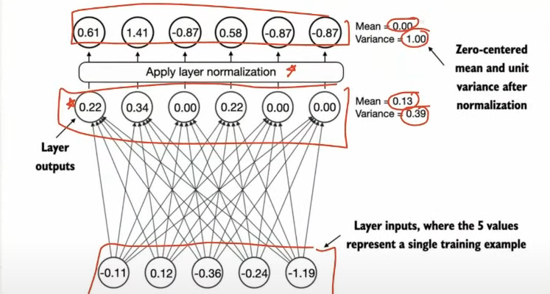

In GPT-2 and modern transformer architectures, layer normalisation is typically applied before and after the multi-head attention module and before the final output layer.

Lecture 21: GELU Activation Function

- We will implement a small neural network sub-module that is a part of the LLM transformer block
- Two activation functions that are commonly implemented in LLMs are:
  - GELU
  - Swi GLU
  - Note: Have an understanding of the dead neuron problem. That's why we don't use the RELU activation function.
- GELU f’n = x * phi(x) where phi(x) → CDF of standard Gaussian distribution
- 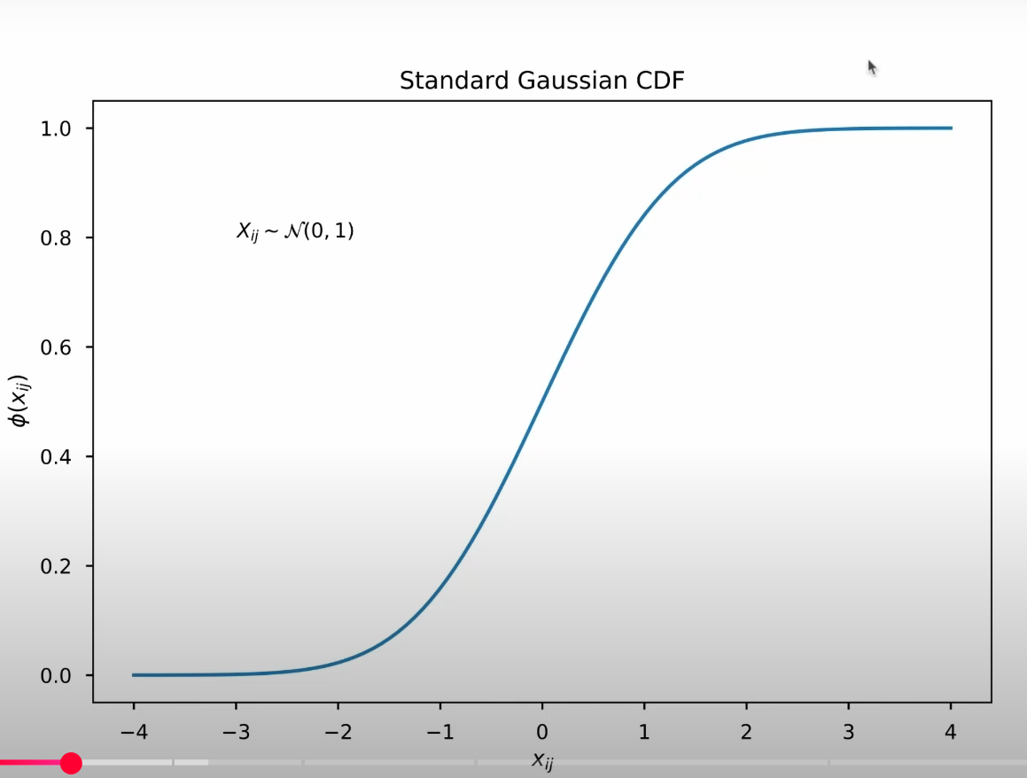
- But in GPT models, we use the GELU activation function approximation used for training GPT-2

- Difference between RELU and GELU
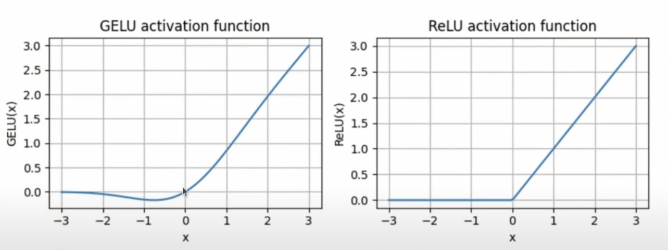

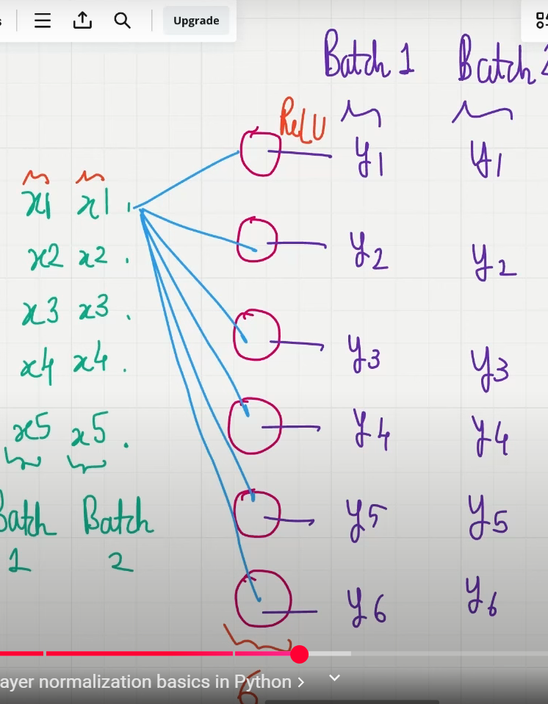

X → Inputs input.shape = (2,5) → 2 batches of inputs, each having 5 inputs
Y → Outputs output.shape = 6
The middle layer has 6 neurons - RELU activation function

Normalization:
- After getting all the Y values for each batch, we apply the layer normalisation

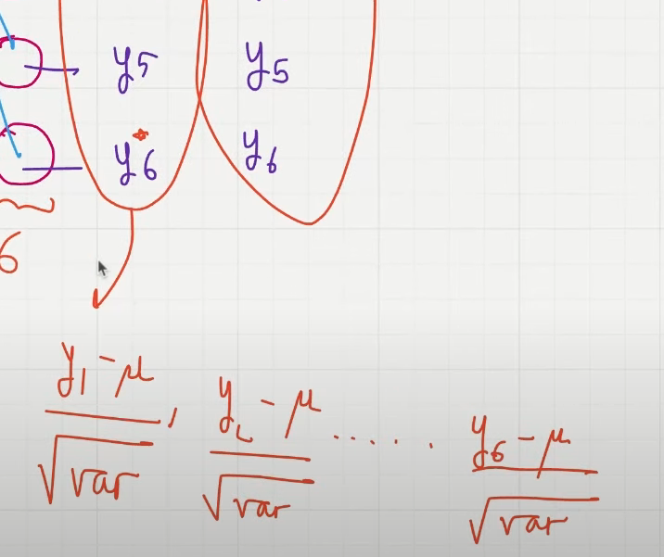

Every Y value is getting replaced by normalisation

Lecture 22: Shortcut Connections

- Also known as Skip or Residual connections
- Shortcut connections were first proposed in the field of computer vision to solve the problem of vanishing gradients.
- Vanishing Gradients: Gradients become progressively smaller as they propagate backwards → making it difficult to train earlier layers.
- Shortcut connections create an alternative path for the gradient to flow, by skipping one or more layers
  - This is achieved by adding the output of one layer to the output of a later layer
  - Play a crucial role in preserving the flow of gradients during training backwards pass

Lecture 23: Coding the entire Transformer Block

- The transformer block is the fundamental building block of GPT and other LLM architectures
- The transformer block is repeated 12 times in GPT-2 small (124M parameters)
- The Transformer Block consists of:
  - Multi-head Attention
  - Layer Normalization
  - Dropout
  - Feed-Forward Layers
  - GELU-Activation
- When a transformer block processes an input sequence, each element is represented by a fixed-size vector
- The operations within the transformer block, such as multi-head attention and feedforward layers, are designed to transform the input vectors such that their dimensionality is preserved - IMPORTANT ADVANTAGE OF TRANSFORMER
- Self-attention → analyses the relationship between input elements
- Feed-Forward Network → Modifies data individually at each position

Lecture 24: Coding the 124 Million Parameter (GPT-2 Model)

- Assembling a fully working version of the original 124 M Parameters version of GPT-2
- Understanding the diagram below (Recap)

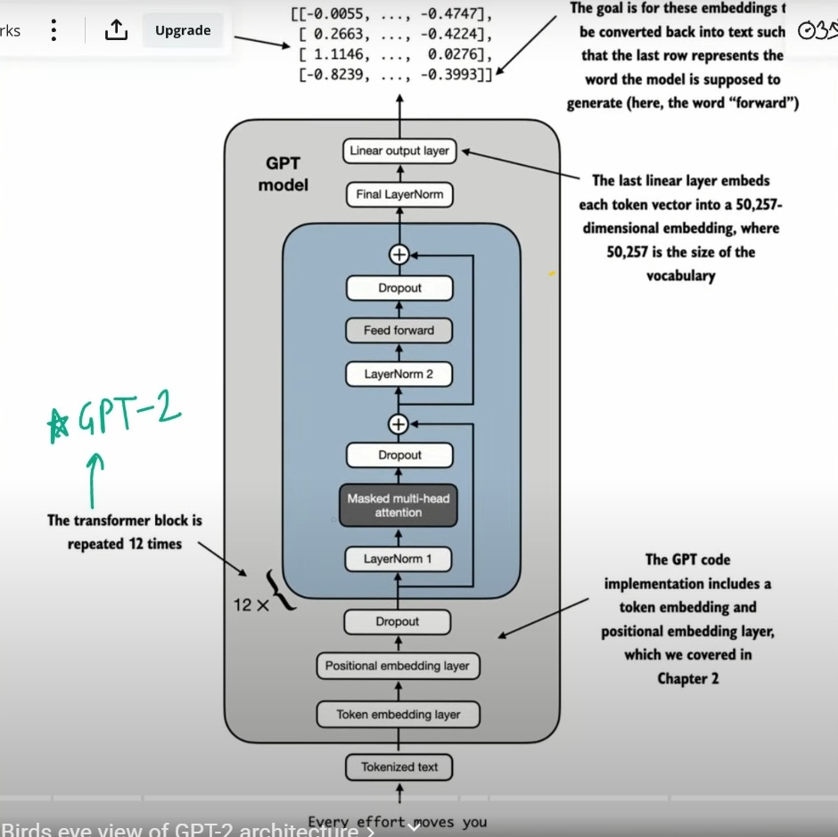

- As we have already explored in detail the Input Block and Transformer Block, we now look into the output stage
- At the very first part of the output stage:
  - The input to the output head will be passing the tokens In this example, we take a context size of 4. The Example is: “Every effort moves you”. Each token with an embedding size of 768.
  - We pass this to a neural network, and the dimension becomes embedding dimensions multiplied by the vocabulary size, so in this case, it is (768x50257)
  - The output will be a logits matrix which will look like this:
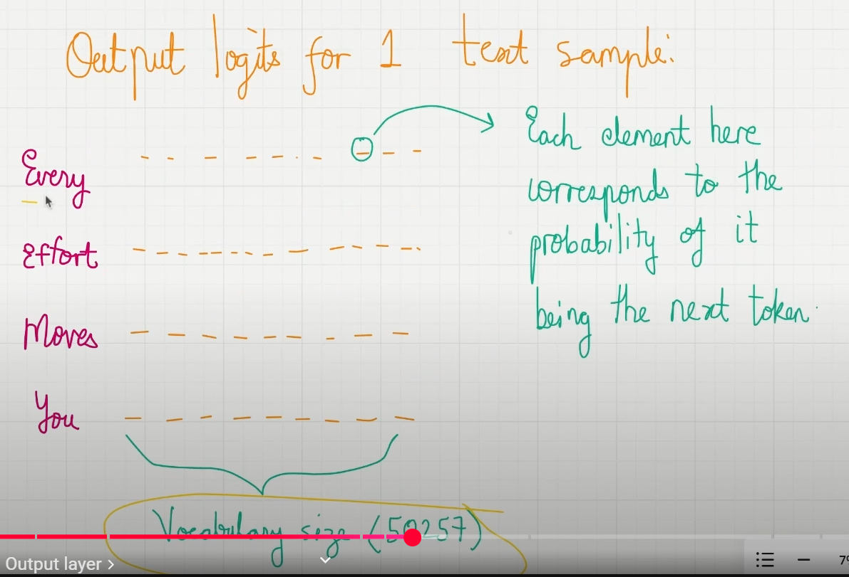

- Each element corresponds to the probability of it being the next token
- Context size = no of prediction tasks. In this example, we do not just have 1 prediction task; rather, we have 4. Final tensor dimension:(1x 4 x 50257). 1 is the batch size

Lecture 25: Coding GPT-2 to Predict the Next Token
- The main tasks LLMs are trained to do are to predict the next token (word) given a context size. Below is a visual diagram
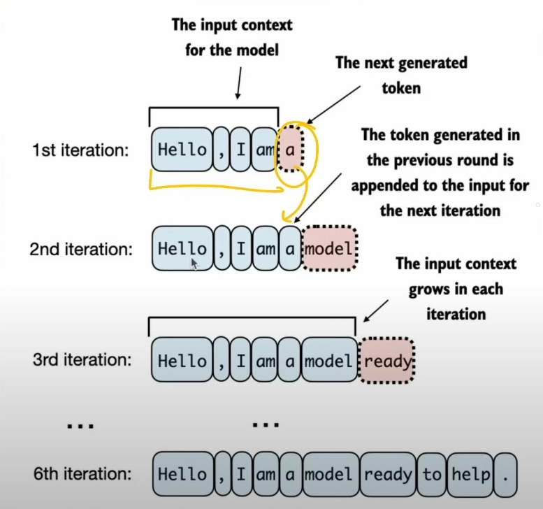
- Now we are looking into how the LLMs are made to predict the next word after the output layer has been formed, which has a dimension of (1x4x50257)
- Steps at a Glance:
  - Step 1: Take the output from the GPT model
  - Step 2: Extract the Last Vector. Here, in this case, it is the token “You”
  - Step 3: Convert the Logits Vector into Probabilities by applying Softmax
  - Step 4: Identify the Index position (Token ID) of the largest Value and decode the Token ID, which will give you the text
  - Step 5: Append Token ID to the Previous Inputs for the next round of Prediction Tasks
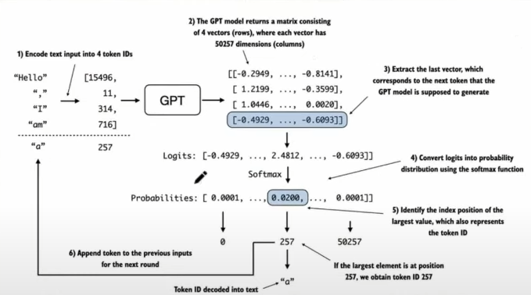

- This step-by-step process enables the model to generate text sequentially, building coherent phrases from the initial input context
- In practice, we repeat this process over many iterations until we reach a user-specified number of generated tokens
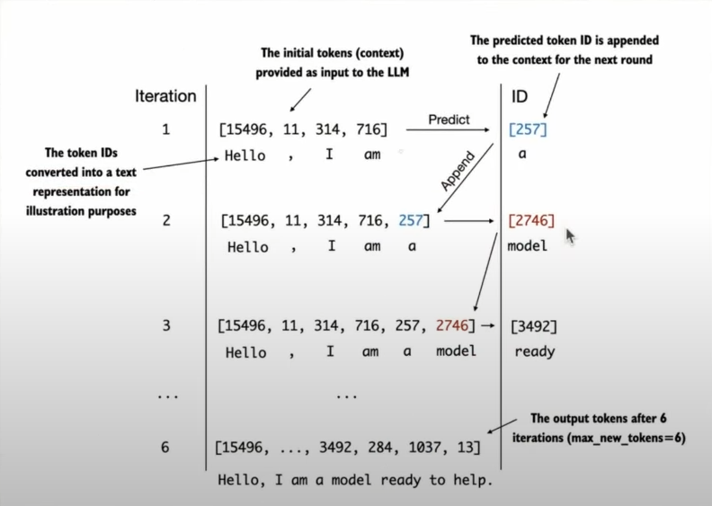

Completion of Stage 1: Building an LLM Architecture
which included:
- Data Preparation and Sampling
- Attention Mechanism
- LLM Architecture

What have we achieved, and the next steps?
Now our GPT Architecture can take a sentence and predict the next word. Now we want to make our predictions better, which happens through training the model. Until now, we have a model where those 124 M parameters are randomised. We need to train the model to get the best possible results.

Lecture 26: Pretraining LLMs’ Loss Function

- How to measure LLM Prediction Loss?

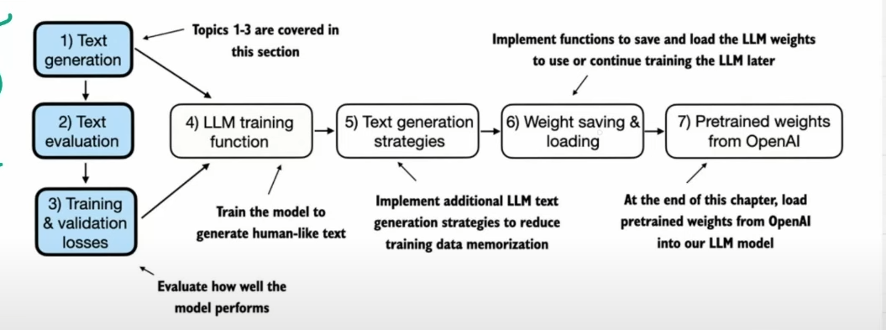

- Text generation is covered in detail in the previous Lectures on how LLMs predict the next word given an input.
- Recap of GPT workings:
  - Step 1: The Tokeniser converts tokens into token IDs
  - Step 2: GPT model converts token IDs into Logits
  - Step 3: Logits are converted back into token IDs

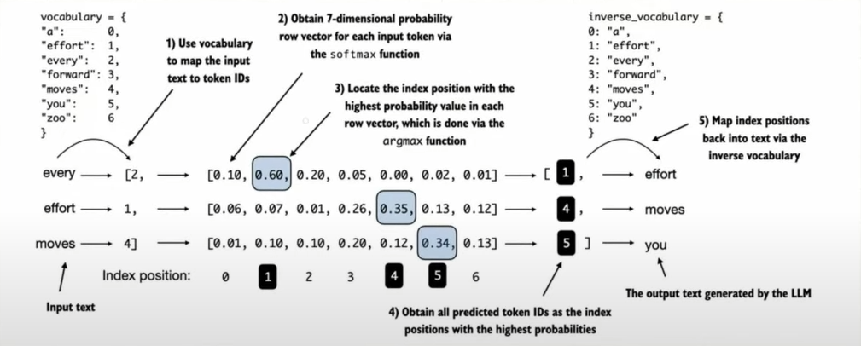

- Now we want to make sure every token ID predicted is as close to the target value.
- In the above diagram, 3 prediction tasks occur (context size = 3): “Every effort moves”
- Finding the loss between Targets and Predicted Outputs
  - Target Indices:
    - Since we know the token IDs of the target tensor, from those token IDs we can get their Probabilities from the Logits Matrix, although currently those values may not be the maximum.
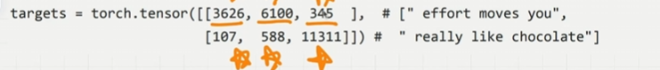

- Basically, from the above target tensor, use those token IDs which serve as the indices in the logits matrix (here dimension 1x4x50257), to extract those token probabilities which are the required prediction values
- Target Probabilities:
  - Batch 1: [p11,p12,p13]
  - Batch 2: [p21,p22,p23]
  - These probabilities were extracted from the target indices
  - The goal of our Training is to get all these probability values as close to 1 as possible, as these values are not necessarily the highest value in the logits matrix.
  - Why do we want these values as close to 1?. Because these are the values we want the LLM to predict as outputs
  - Merge them together [p11,p12,p13,p21,p22,p23]
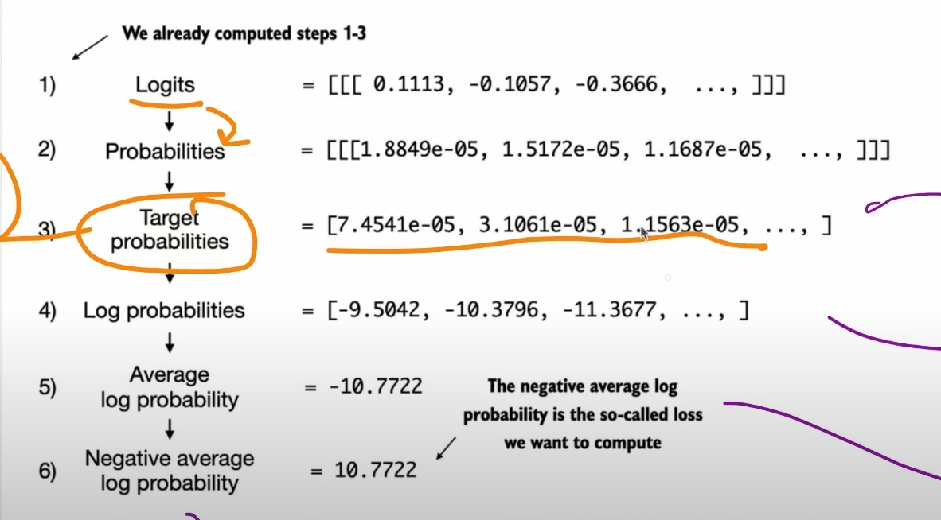
- The final value 10.7722 is the cross-entropy loss, and this is the loss we want to minimise as much as possible
- Perplexity: Another Loss Measure like cross-entropy
  - Measures how well the probability distribution predicted by the model matches the actual distribution of words in the dataset.
  - A more interpretable way of understanding model uncertainty in predicting the next token.
  - Lower perplexity score = Better predictions
  - Perplexity = e^{Loss} here it is = 48725
  - This number 48725 tells us that the model is roughly as uncertain as if it had to choose the next token randomly from about 48725 tokens in the vocabulary

Lecture 27: Evaluating LLM Performance on a Real Dataset
- This Lecture is mostly a repeat of the previous lecture. We are only adding a Dataset to train our model.
- Dataset - Verdict by Edith Wharton
- Link - Verdict

Lecture 28: Coding The Entire LLM Pretraining Loop

Schematic:

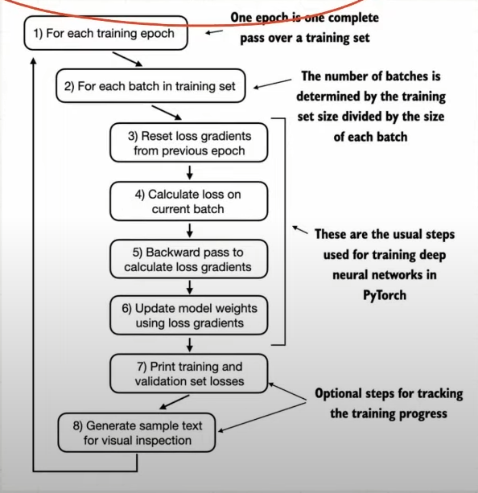

Lecture 29: Temperature Scaling in LLMs

- Until now, the generated token is selected corresponding to the largest probability score among all tokens in the vocabulary
- Leads to a lot of randomness and diversity in generated text
- We will learn 2 techniques to control this randomness
  - Temperature Scaling
  - Top - K Sampling
- Temperature Scaling:
  - Replace Argmax with a probability distribution
  - Multinomial Probability distribution samples the next token according to the probability score
  - What is Temperature: A Fancy term for dividing the logits by a number greater than zero
  - Scaled logits = logits/temperature. This scaled logits is passed through softmax → multinomial sampling
  - If the temperature is too low, it leads to a sharper distribution. Almost no variability or creativity.
  - If the Temperature value is too high leads to a flattened distribution (more variety, but also more nonsense)
  - Why the name temperature? → Low temperature leads to low randomness, which is associated with low entropy. Higher temperature leads to higher randomness, which is associated with high entropy

Lecture 30: Top-K Sampling in LLMs

- Restrict the sampled tokens to the Top K most likely tokens and exclude all other tokens

Lecture 31: Loading and Saving LLM Model Weights Using PyTorch

- Let's Learn how to load and save a pretrained model
- The two most important functions offered for this in PyTorch are:
  - torch.save(model.state_dict(), “model.pth”) - model.state_dict() is a dictionary mapping each layer to its parameters and model.pth is the saved file name
  - model.load_state_dict(torch.load(“model.pth”)) - this is to load a saved model which is present in the file model.pth
- Just like how we have saved and loaded the learnable parameters (weights & biases) of our model, it is also good practice to constantly save the optimiser state as well
- We can do this by optimizer_state_dict offered by PyTorch, which saves the model hyperparameters and historical data, such as past gradients
- We can do both of these using the torch.save() function

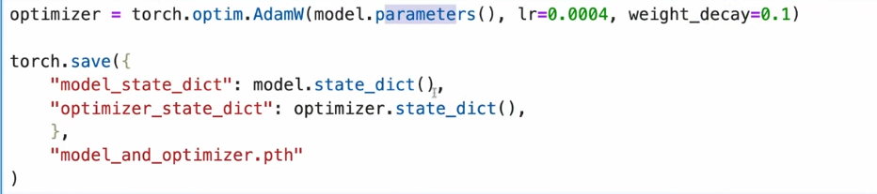

Lecture 32: Loading Pre-trained weights from OpenAI GPT-2

- Note that OpenAI originally saved the GPT-2 weights via TensorFlow, which we have to install to load the weights in Python. And we use a progress bar tool called tqdm to track the download process
- Parameter Dictionary Keys:
  - Wte: Token Embeddings
  - Wpe: Positional Embeddings
  - Blocks (Trainable Parameters Present in the transformer block)
    - Attention Layers in transformer blocks
    - Feedforward neural network weights in the transformer block
    - Output projection layer in the transformer block
    - Layer Normalization
  - g: Final norm scale
  - b: Final norm shift
- Params dictionary has 5 keys in itself, which are mentioned above: [Wte, Wpe, Blocks,g,b]
- And within the Blocks, this is how it looks:

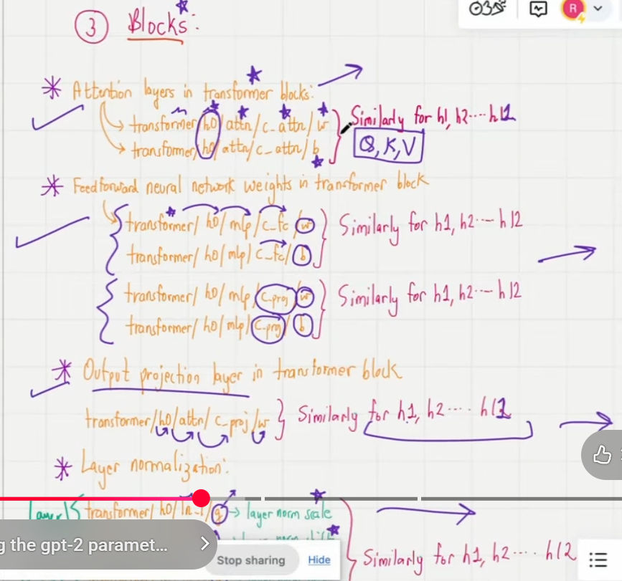

- The load_gpt2_params_from_tf_ckpt function takes the parameters which is present in the tf_ckpt_path and tries to load them in the format mentioned earlier, and returns params and settings just as we wanted

